  - Approved 2026/27 Transmission Loss Adjustment Factors (TLAFs)
  - Accompanying Note
  - Version 1.1
17th August 2026

Background
This explanatory paper has been prepared by the Transmission System Operators (TSOs) to accompany the proposed Transmission Loss Adjustment Factors (TLAFs) which have been calculated by the TSOs, based on the approved TLAF methodology (SEM-12-049), for 2026/27 (1st October 2026 to 30th September 2076). TLAFs for interconnectors under the revised SEM arrangements are detailed in the I-SEM Interconnector Losses Information Paper published 02 June 2017.

TLAF Methodology
The methodology for calculating TLAFs is defined and published as Transmission Loss Adjustment Factor (TLAF) Calculation Methodology. Electrical losses occur as electricity is transported along networks from generators/interconnectors to demand centres. Losses occur on both the transmission and distribution networks which, must be accounted for in SEM market settlement. In SEM, all market settlement is assumed to take place at the interface between the transmission and distribution grids. Transmission losses are allocated to generators/interconnectors, by means of TLAFs. Some units are responsible for proportionally more transmission losses than others depending on their point of connection to the grid. For this reason, TLAFs are site specific. At present the following parties that participate in the SEM (market participants) are subject to TLAFs:
- Generators connected to the transmission network,
- Generators connected to the distribution network,
- Interconnectors, and
- Supplier TLAFs (the Trading and Settlement Code (TSC) specifies that TLAFs for Supplier Units are set equal to 1.0).

The purpose of TLAFs is to allocate transmission losses to market participants in a fair and equitable manner that is reflective of their contribution to transmission losses. The TLAFs therefore promote efficient dispatch. The principle is that market participants that contribute more to transmission losses due to their location should have a lower TLAF than those generators who contribute less to transmission losses.
TLAFs reflect the extent to which a market participant increases or reduces transmission losses. Factors that impact TLAFs include:
- Generation/interconnector dispatch quantities which determine the power flows on transmission lines,
- The level of demand in a particular area,
- Changes to the transmission network topology, and
- The commissioning or decommissioning of generation/interconnector connections can result in changes in network topology and transmission power flows.

TLAF Analysis - Overview
Following a comparison between 2025/26 and 2026/27 it was found that most nodes have seen their TLAFs decrease. 94.55% of the TLAFs calculated are within 1% of the previous year’s TLAFs and 99.77% are within 2%. The maximum average participant TLAF change is 2.27%. The overall average TLAF has decreased by 0.15% from 2025/26.
The normal distribution and the frequency distribution are shown below in Figure 1 and Figure 2 respectively.

Figure 1 – Normal Distribution of changes in TLAFs from 2025/26 to 2026/27

Figure 2 – Frequency Distribution of changes in TLAFs from 2025/26 to 2026/27

TLAF Analysis - Regional
Figure 3 shows an all-island overview of the TLAFs for 2026/27, indicating the locational range. Green signifies nodes with high TLAFs, while red signifies nodes with lower TLAFs. The TLAFs on the west tend to be lower than those on the east. This shows that the TLAF model is providing a valid signal, as it aligns with the expectation that generators contributing more to transmission losses due to their location should have a correspondingly lower TLAF.
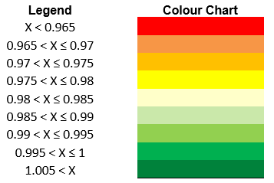

Figure 3 – Locational breakdown of 2026/27 TLAFs
The change in TLAFs from 2025/26 to 2026/27 is shown in Figure 4. Yellow signifies nodes where TLAFs have declined from their respective values in 2025/26, with dark orange representing the largest change. Green represents the node with an improvement, while white block represents no significant change. EWIC, Moyle and Greenlink TLAFs are fixed as per the I-SEM Interconnector Losses Information Paper. The main observations from this graph are as follows:
- Average TLAFs have decreased on an all-island basis from their respective values in 2025/26.
- TLAFs on the West, North West have decreased in 2026/27 model compared to 2025/26 TLAFs
- TLAFs in East, South East and South West have increased in 2026/27 model compared to 2025/26 TLAFs
- TLAFs in Northern Ireland have decreased in 2026/27 model compared to 2025/26 TLAFs
-0.24%
-0.14%
-0.23%
-0.51%
-0.03%
-0.15%
-0.08%
-0.06%

-0.18%
-0.01%

-0.20%
-0.08%

-0.21%
-0.31%
-0.21%

-0.19%
-0.50%
-0.30%

-0.10%
-0.07%
-0.47%

-0.33%

-0.02%
-0.05%
-0.29%
-0.31%
-0.27%
-0.22%
-0.38%
-0.27%
-0.38%
-0.39%
-0.30%
-0.37%
-0.02%
-0.26%
-0.38%
-0.27%

-0.02%

-0.33%
-0.43%

-0.12%

-0.28%
-0.11%
-0.01%

-0.10%

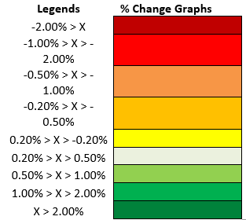
Figure 4 –TLAF changes from 2025/26 to 2026/27
Many factors have driven the change in TLAFs between the two years in question. A key factor that can help explain changes between TLAFs in 2 different years is the changes in regional dispatches assumed in the respective models.
There is a link between regional dispatch change and the TLAF trend in that region. However, it’s important to note that while changes in dispatch between years will change base case flows, they do not indicate how an individual participants generation will impact flows. Instead, it may provide an indicator for possible expected regional changes rather than on an individual generator basis.
There has been a change in direction of interconnector power flows assumed in the models since 2023/24. The interconnectors have changed from being a net exporter until 2023/24 to a net importer onwards. With greater interconnector imports assumed in the model, they supress the requirement for more remote generators to support the demand centres.
The TLAFs in the west and northwest have decreased in 2026/27 compared to 2025/26. There is less generation assumed on the west coast in 2026/27 compared to 2025/26. This is due to a combination of less thermal generation and wind generation assumed in both regions in 2026/27.
Under the Security of Supply programme, the ESB units (MP1, MP2, MP3) at Moneypoint are contracted to remain open but for the 2026/27 tariff year they will behave like TEG units under the Targeted Contracting Mechanism (TCM). As a result, there was no dispatch considered from any of these units in all of the TLAF assessments as the units will only be dispatched by the TSO when the system is near or in alert. This had the effect of improving the TLAF of all other participants in the vicinity.
The TLAFs in the Southeast have increased in 2026/27 model compared to 2025/26 TLAFs. This is likely due to an increase in the generation in this region predominantly due to the downturn in forecasted import via Greenlink. This revised forecast decrease is due to the actual Greenlink imports being lower than the forecasted imports from 2025/26.
Figure 5 shows the total regional MW dispatch change, inclusive of the interconnector imports from 2026/27 to 2025/26. For commercial sensitivity reasons, data is shown at a regional level, and aggregated from all generation types, (thermal, wind, solar, etc.)
As previously stated, although regional changes from one year to the next can be generalised using Figures 4 and 5, they should not be used as the single determinant for TLAF changes. A participant’s TLAFs are a result of how generation at its node will offset, or add to, all-island base case flows. This graph shows that there is a general link between the change in dispatch and changes in TLAFs within a region, i.e. this year, there is less generation assumed on the west coast compared to last year, resulting in a lower TLAF this year compared to last year.

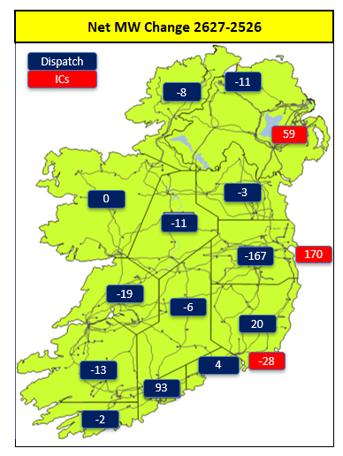
Figure 5 – Total regional MW dispatch change from 2025/26 to 2026/27

The TLAF for Greenlink has been updated from the 2024/25 approved figure to its actual TLAF determined through commissioning testing in January 2025.

