System Margins Outlook
Northern Ireland

This report is issued every Monday and Friday, excluding bank holidays.

Disclaimer:
While reasonable care and precaution has been taken to ensure its accuracy, this report and the information contained herein is provided without warranties or representations of any kind with respect to (without limitation) its quality, accuracy and completeness. All information contained herein is subject to change without notice.
SONI (as Transmission System Operator for Northern Ireland) takes no responsibility for any inaccuracies, errors or omissions in this report, and excludes to the fullest extent permitted by law liability for any loss or damage arising from use of this report or reliance on the information contained herein. Any actions taken on foot of this report and the information contained herein are taken at the user’s sole risk and discretion, and parties are advised to seek separate and independent opinion in relation to matters covered by this report.
Date: | 1st June 2026
Time: | 12:15


Outlook
Daily Dispatch Margin and Renewable Generation Forecast
The outlook for the Daily Dispatch Margin (green) and the renewable energy generation forecast is shown below. The renewable generation forecast comprises grid-scale solar and wind energy. The probable low renewable generation between 09:00 and 21:00 (when peak system demand occurs) is shown in dark blue. The average forecast renewable generation between 09:00 and 21:00 is shown in light blue. The renewable generation forecast is shown for four days ahead. If the Daily Dispatch Margin combined with renewable generation is below the operating margin (approximately 400 MW), support via trades and flows on interconnectors between Northern Ireland and Great Britain or Ireland is required to avoid a System Alert.
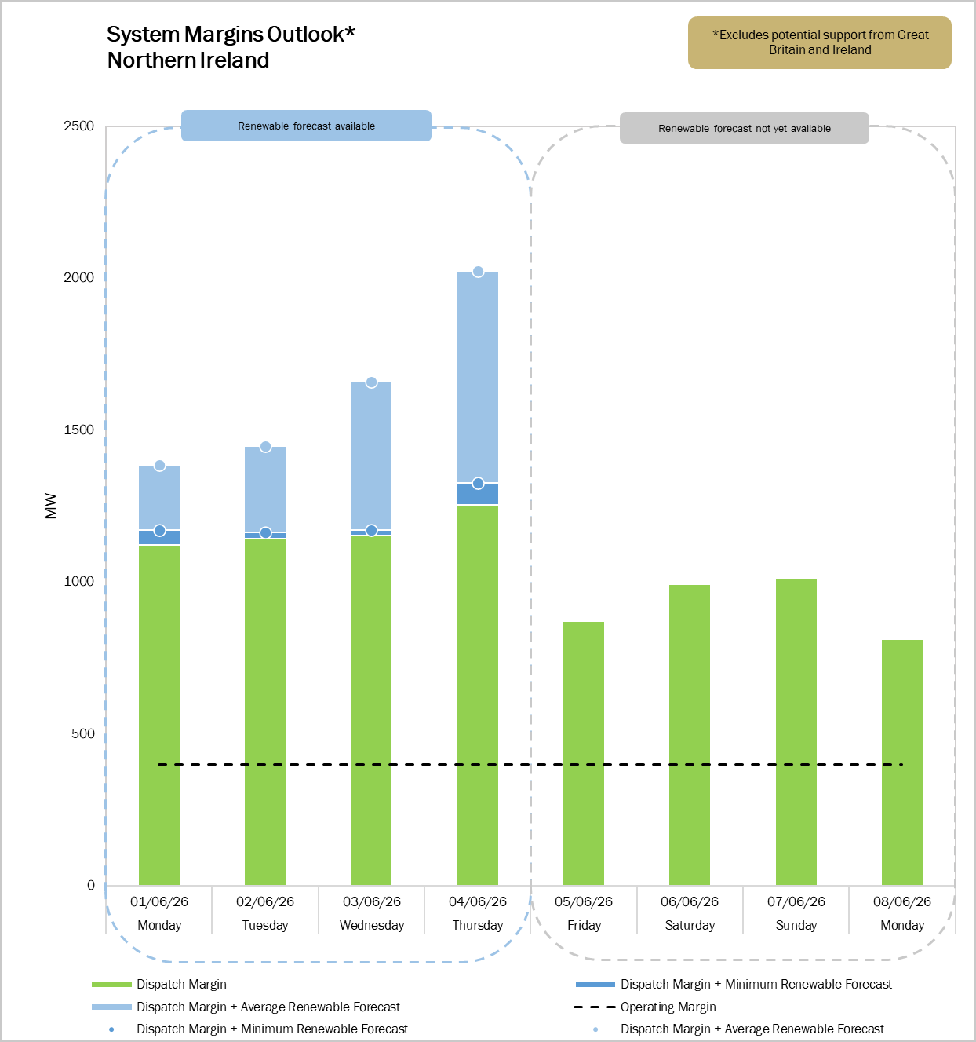
When a negative dispatch margin coincides with a low renewable generation forecast, the net renewable generation value may appear below the zero axis (low forecast: ●, average forecast: ●). It should be noted that the Daily Dispatch Margin and renewable generation forecast are highly variable. The outlook is based on estimates and is therefore subject to rapid changes.
Interconnector Availability
Imports via interconnectors will be subject to trades on the day. The outlook for the maximum import capacity from Great Britain to Northern Ireland is shown below.
Interconnector  Availability (MW) | Mon | Tue | Wed | Thu | Fri | Sat | Sun | Mon
Moyle | 450 | 450 | 450 | 450 | 450 | 450 | 450 | 450
Description of Terms
 | Summary
Daily Dispatch Margin | The Daily Dispatch Margin (green) is the anticipated difference between how much dispatchable capacity (generation, batteries, and demand response) is expected to be available to the System Operator, and the forecast peak system demand on the day. The margin takes into consideration local grid constraints.  When the margin is negative, available generation is inadequate to meet demand if supply from other sources is not available on a given day. Other sources include renewable generation, flows from Ireland to Northern Ireland via the North-South Tie-Line, and trades (imports) from Great Britain via the Moyle Interconnector.  This margin can change on any given day, should generation capacity unexpectedly become unavailable due to forced outages or if the demand forecast changes.
Renewable Generation | The installed grid-scale wind and solar generation capacity in Northern Ireland is approximately 1,450 MW and 140 MW respectively. When renewable generation is high, the quantity of dispatchable generation required to meet demand and operational security requirements is reduced.  Given the variability in the renewable generation forecast, the impact on the margin of a probable low value (dark blue) and a probable average value (light blue) is shown in the outlook.
Operating margin | In order to operate the power system securely (i.e. to exceed the ability to meet demand), the Transmission System Operator makes provision for loss of a single largest source of capacity on the day. This operating margin is indicated by a 400 MW provision in the outlook (black).
System Alert | A System Alert (Amber) will be issued by the System Operator on a given day if the operating margin is not met by a combination of available generation, imports and renewable generation (i.e. loss of the single largest unit).
System Emergency | A System Emergency (Red Alert) will be issued in real time by the System Operator on a jurisdictional basis if there is a high probability that controlled demand reduction may be required, or if this has been instructed. Controlled demand reduction includes procedures for large energy users to curtail demand and for customers to be temporarily disconnected to secure the power system.

Renewable Generation
link
Daily Dispatch Margin
Peak
Demand
Forecast
link
Dispatchable Generation, Batteries & Demand Response

Planned and forced outages
link

If the Daily Dispatch Margin is below the required operating margin, renewable generation and flows/imports from Ireland and Great Britain are required to avoid system alerts
Tie-Line and Interconnector support
link

Required
Operating
Margin

