**Northern Ireland Monthly Electricity Statistics Update – September 2012**

**System Statistics and Records:**

|  |  |  |
| --- | --- | --- |
| Monthly Electricity Demand | 688.51GWh | *September 2012* |
| Monthly Electricity Demand From Renewables [1] | 118.68 GWh | *Sept 2012 (Wind3 = 111.47 GWh)* |
| Monthly Electricity Demand Growth Rate | **-1.28%** | *Sept 2012 v Sept 2011* |
| Year To Date Electricity Demand Growth Rate | **-1.74%** | *Jan-Sept 2012 vs Jan-Sept 2012* |
| Monthly Maximum Load | 1412 MW | *Sept 2012* |
| Monthly Minimum Load | 569 MW | *Sept 2012* |
| 2012 Year To Date Maximum Load | 1671MW | *17:30 hrs on Wednesday 4th January 2012* |
| 2012 Year To Date Minimum Load | 516 MW | *06:00 hrs on Sunday 1st July 2012* |
| All Time Maximum Peak Demand | 1777 MW | *18:00 hrs on 22nd December 2010* |
| Installed Dispatchable Capacity[2] | 2336 MW | *As at 31st Aug 2012* |
| Installed Renewable Capacity1 | 484MW | *As at 30thSept 2012 (Wind3 = 463 MW)* |
| 2012 Maximum Wind Output[3] | 395 MW | *16:30 hrs on 13th September 2012* |

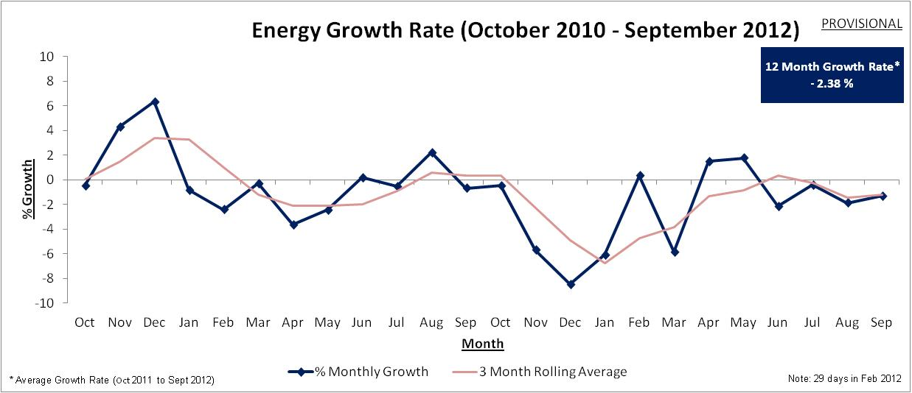

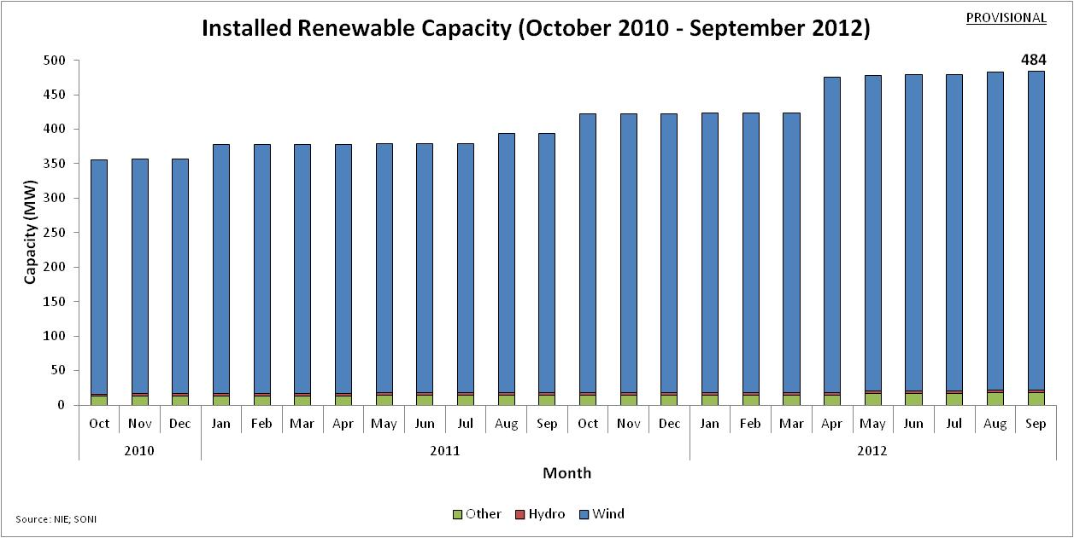

1. **Includes Large Scale Wind (≥1 MW = 450.9 MW), Small Scale Wind, Hydro, Tidal, Biomass, PV and Landfill Gas**
2. **Excludes import capacity of Moyle. (Import = 450MW Nov-Mar & 410MW Apr-Oct. Export = 295MW Sep-Apr & 287MW May-Aug).**
3. **Includes Large Scale Wind and Small Scale Wind**